In Class Exercise for Advanced SQL

Create the following table. Ensure that id is a primary key

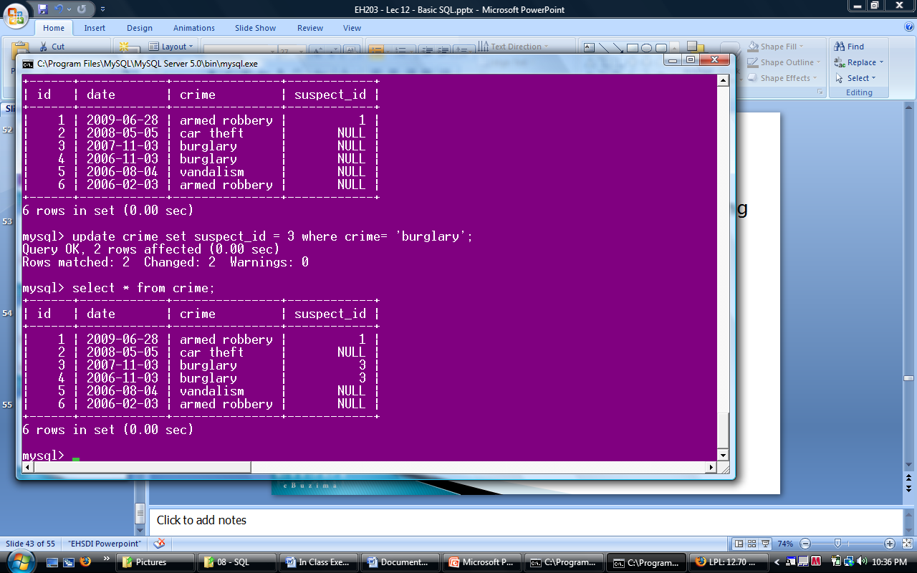

Create the following suspects table. Ensure that id is a primary key

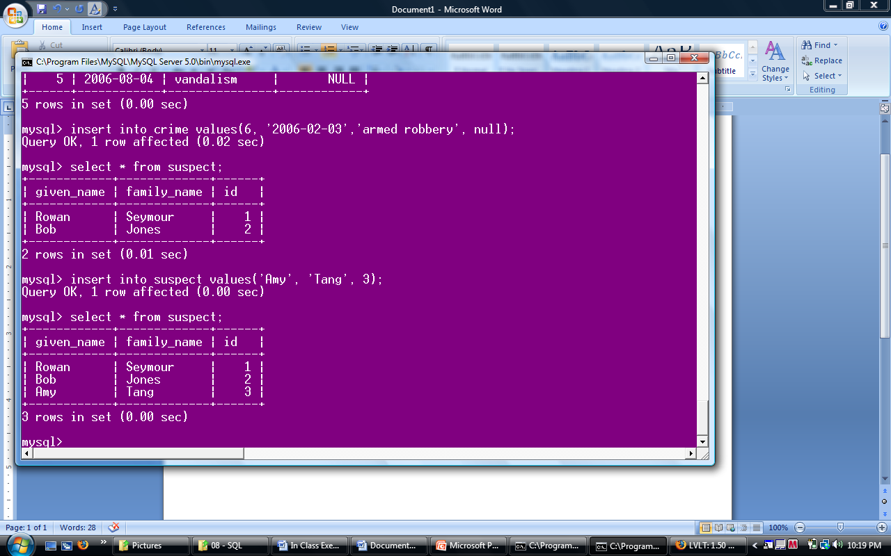

1. Write a query to show the number of records with null values in the suspect_id column

select count(*) from crime where suspect_id is null;

1. Show only the records in the crime table which have a matching id in the suspect table

select * from crime inner join suspect on crime.suspect_id = suspect.id;

1. Show all the records in the crime table and only those from the suspect table having a matching id

select * from crime left join suspect on crime.suspect_id = suspect.id

1. Show all the records from the suspect table and show only the crime records with suspect_ids matching the id field in the crime table

select * from crime right join suspect on crime.suspect_id = suspect.id

Create the following houses table. Ensure that id is a primary key

` 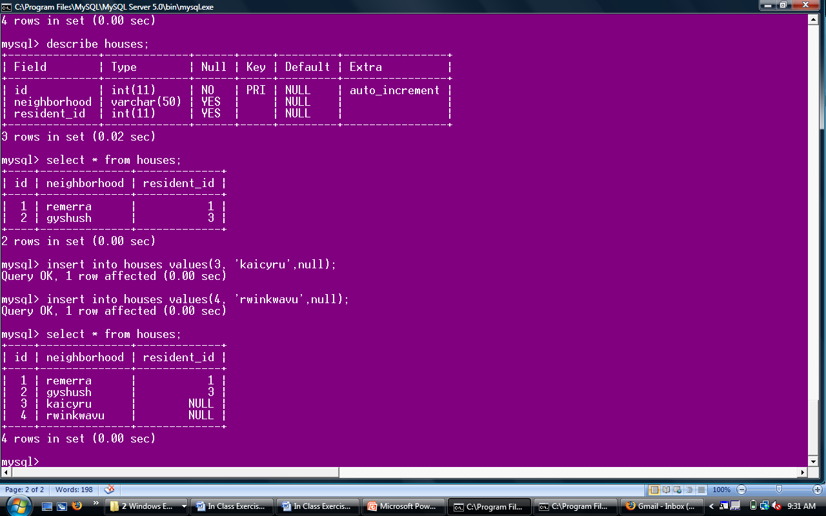

1. Show only the neighborhood that have residents in the suspect table, the suspect’s given name, and only the crimes committed by those residents

select n.neighborhood,s.given_name,c.crime from (neighborhood as n inner join suspects as s on n.id=s.id) inner join crime as c on c.id = s.id;

1. Show all existing neighborhoods, the residents that live in those houses and all existing crimes

select * from (houses left join suspects on house.resident_id = suspect.id) right join crime on crime.suspect_id = suspect.id

1. Modify the suspects table to ensure the family name will never have a null entry

alter table suspects modify family_name varchar(50) not null;

1. Alter table houses and change the neighborhood column name to village

alter table house change neighborhood village varchar(30);

1. Alter the houses table and add a column to for country

alter table house add column country varchar(30);

1. Add a constraint to ensure that id is unique

alter table test add constraint unique(id2);

alter table suspect modify id int unique;